 | Reg. No:  SRI RAMAKRISHNA ENGINEERING COLLEGE,COIMBATORE  Regulation- 2020 (ES)  (Autonomous Institution, Reaccredited by NAAC with ‘A+’ GRADE Approved by AICTE and Permanently affiliated to Anna University, Chennai)  AUTONOMOUS EXAMINATIONS – MAY/JUNE'2022
B.E – COMPUTER SCIENCE AND ENGINEERING
20CS210 - PROGRAMMING PARADIGMS III
Answer ALL questions
Duration: 3 Hours |  |  |  |  |  | Maximum: 100 Marks
 |  |  |  |  |  |  |  |  | PART - A |  |  |  |  |  | (7x 1 = 7 Marks)
1. | CO1 |  |  | Find the output of the following python code snippet.  y = 6  z = lambda x: x * y  print z(8)
 |  |  |  | a) 14 |  |  |  |  |  |  | b) 45 |  | c) 48 |  |  |  | d) 24
2. | CO1 |  |  | Consider the following dictionary.  marks ={"Quizzes":{"Mahesh":[3,5,7,8],  "Suresh":[9,4,8,8],"Uma":[9,9,7,6]},"Exams":{" Mahesh":[37],"Uma":[36]}}  Which of the following statements does not generate an error?
a) marks["Exams"]["Suresh"].extend([44])
b) marks["Exams"]["Suresh"].append(44)
c) marks["Exams"]["Suresh"][0:] = [44]
d) marks["Exams"]["Suresh"] = [44]

3. | CO3 |  |  | Which of the following is a complete event-driven networking framework to develop complete asynchronous networked applications and protocols?
 |  |  |  | a) SocketServer |  |  |  |  |  |  | b) Twisted |  | c) Reactor |  |  |  | d) Socket
4. | CO3 |  |  | The data-preserving feature of Django that disallows POSTs and are not secure against ___________ attacks.
 |  |  |  | a) CSRF |  |  |  |  |  |  | b) Brute Force |  | c) DRY |  |  |  | d) Blog
5. | CO3 |  |  | Which of the following thread method is used to wait until it terminates?
 |  |  |  | a) waitforthread() |  |  |  |  |  |  | b) wait() |  | c) waitall() |  |  |  | d) join()
6. | CO3 |  |  | _________ a cross-platform toolkit that can be used to build GUI applications.
 |  |  |  | a) Tkinter |  |  |  | b) wxWidgets |  |  |  | c) Python mega widgets |  |  |  |  | d) Tix
7. | CO3 |  |  | Which of the following is the default authentication for App Engine application?
 |  |  |  | a) Open ID |  |  |  |  |  | b) Google Accounts |  |  |  | c) Yahoo |  |  | d) Flickr
Fill in the blanks: |  |  |  |  |  |  |  |  |  |  |  |  |  |  |  | (3x 1 = 3 Marks)
8. | CO3 |  |  | The __________ method is called when the URL /post or /post/edit/X is accessed.
9. | CO1 |  |  | ____________ is the abstract class to develop Web servers.
10. | CO2 |  |  | ___________ operates in a fashion similar to FTP and is much simpler.
 |  |  |  |  |  |  | PART - B |  |  |  |  |  |  |  |  | (5x 3 = 15 Marks)
11. | CO1 |  | Illustrate the advantages of Tuple over List?
12. | CO4 |  | Build a python program to print twitter user name.
13. | CO3 |  | Differentiate between Django project and Django App.
14. | CO1 |  | Develop a Python program to remove duplicates from dictionary.
15. | CO2 |  | Summarize the purpose of Web Framework.
 |  |  |  |  |  |  |  |  | PART - C |  |  |  |  |  | (5 x 15 = 75 Marks)
Q.No: 16 Compulsory Question
Q.No: 17 to 22 Answer any FOUR Questions
Compulsory Question:
16. | CO3 |  | i) |  | Outline Python and ORMs with an example. |  |  |  |  |  |  |  |  |  |  |  |  | (8)
 | CO3 |  | ii) |  | Summarize Python Web Client Tools with examples. |  |  |  |  |  |  |  |  |  |  |  |  | (7)
17. | CO1 |  | i) |  | Develop a python program to find the number of instances of different digits in a given number. |  |  |  |  |  |  |  |  |  |  |  |  | (7)
 | CO1 |  | ii) |  | Discuss the exception handling in python using example programs. |  |  |  |  |  |  |  |  |  |  |  |  | (8)
18. | CO3 |  |  |  | Develop the given student registration form GUI using Python tkinter module. Connect a data base to store the registration details while submitting the form. (All the fields need to be validated for successful submission)  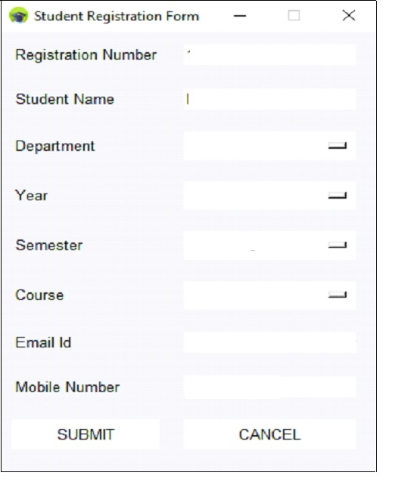 |  |  |  |  |  |  |  |  |  |  |  |  | (15)
19. | CO2 |  | i) |  | Outline python classes and inheritance with examples. |  |  |  |  |  |  |  |  |  |  |  |  | (7)
 | CO3 |  | ii) |  | Create a simple GUI application using any two of the most popular toolkits other than Tkinter. |  |  |  |  |  |  |  |  |  |  |  |  | (8)
20. | CO2 |  | i) |  | - Separate the last name and first name of three students using regular expression.  - Extract the months from the timestamps.  - Replace the e-mail address from each line of data with your e-mail address. |  |  |  |  |  |  |  |  |  |  |  |  | (8)
 | CO2 |  | ii) |  | Summarize the steps involved in transferring file using TCP socket and to develop a python program for the same. |  |  |  |  |  |  |  |  |  |  |  |  | (7)
21. | CO4 | i) |  |  | Discuss the process of developing a Hello World Application into a simple Blog using Django Framework. |  |  |  |  |  |  |  |  |  |  |  |  | (8)
 | CO4 | ii) |  |  | Develop a python program to extract Twitter data. |  |  |  |  |  |  |  |  |  |  |  |  | (7)
22. | CO3 | i) |  |  | Develop a Feedback page using Python-CGI with database. Take user feedback via a form, process the data in the python script, and then return a thank you screen. |  |  |  |  |  |  |  |  |  |  |  |  | (7)
 | CO4 | ii) |  |  | Develop a Hello World Application using AppEngine’s Web App Framework. |  |  |  |  |  |  |  |  |  |  |  |  | (8)
*****

